SIMATS ENGINEERING
ASSESSMENT TOOL 3
COURSE NAME: INTERNET PROGRAMMING
COURSE CODE: CSA43
COURSE OUTCOME COVERED
CO-1: Develop well-structured, standards-compliant web pages using HTML/XHTML and XML, and apply Internet protocols and HTTP communication mechanisms for web content delivery. (L2)
Assessment Tool : Case Study
Weightage: 10%
QUESTIONS: Total Marks: 10

Scenario: Web Development Standards Implementation
A startup is developing a modern web application. During development, the team encounters multiple issues related to HTML elements, HTTP methods, XML syntax, and web communication protocols.
The following observations are made:
- The team needs to embed a promotional video on the homepage.
- A registration form must securely send user data to the server.
- The navigation menu must follow semantic HTML standards.
- XML configuration files are being used but contain syntax errors.
- The application must communicate over the correct web protocol.

Data Snippets Provided

Snippet 1: Video Embedding Options
A. <media src="video.mp4"></media> B. <video src="video.mp4" controls></video>
- <movie src="video.mp4"></movie>
- <vid src="video.mp4"></vid>

Snippet 2: Form Submission Methods
- GET
- POST
- PUT
- DELETE

Snippet 3: Navigation Elements
- <div>
- <nav>
- <section>
- <header>

Snippet 4: XML Syntax
- <note><to>User</to><from>Admin</from>
- <note><to>User</to><from>Admin</from></note>
- <note><to>User</from></note>
- <note to="User"></note

Snippet 5: Web Communication Protocols
- FTP
- HTTPC. SMTP
D. SNMP
Questions:
- Select the correct HTML tag for video embedding and justify your answer.
- Identify the appropriate HTTP method for form submission and explain why.
- Choose the proper semantic element for navigation and justify its usage.
- Identify the correct XML syntax and explain the error in other options.
- Choose the correct protocol for web communication and justify your choice.

Code of Conduct:
I _R.Asif(192411163)__ (Name / Reg No) certify that this submission is my original work and that I have adhered to the guidelines specified for this assessment. I understand that any violation of academic integrity rules will result in disciplinary action.
Signature of the student:R.Asif
RUBRICS FOR CALCULATION:

Criteria | Weightage | Level 4 –  Exemplary | Level 3 –  Proficient | Level 2 –  Developing | Level 1 –  Beginning
Understanding of Case | 25 | Thorough understanding;  clearly identifies all key issues | Good understanding with most issues identified | Basic understanding  ; some issues missed | Poor understanding;  problem not  identified correctly
Application of  Concepts | 25 | Effectively applies relevant concepts to  analyze the case deeply | Applies appropriate  concepts with minor gaps | Limited application of concepts | Fails to apply relevant concepts
Analysis | 20 | In-depth analysis with strong  reasoning and insights | Good analysis with logical reasoning | Basic analysis with limited depth | Weak or no analysis; lacks reasoning
Solution  Design | 20 | Innovative, feasible  solutions with strong justification | Logical solutions with adequate justification | Basic solutions with weak justification | Incorrect or no solution provided
Clarity | 10 | Clear, wellstructured, and easy to understand | Organized and understandable  presentation | Limited clarity and structure | Poor clarity; difficult to understand

Answers
Question 1: Select the correct HTML tag for video embedding and justify your answer.

Correct answer: Option B — `<video src="video.mp4" controls></video>`

Explanation:

The HTML `<video>` tag is used to embed video content in a webpage. The `src` attribute specifies the video file, and the `controls` attribute displays playback controls such as play, pause, and volume.

The other options (`<media>`, `<movie>`, and `<vid>`) are not standard HTML video elements.

Separate Code — Question 1

Save as `question1.html`.

```

<!DOCTYPE html>
<html>
<head>
<title>Video Embedding</title>
</head>
<body>
<h2>Promotional Video</h2>

<video src="video.mp4" controls width="400">
Your browser does not support video.
</video>
</body>
</html>

```

Expected output:

- A heading: Promotional Video
- A video player with playback controls, provided `video.mp4` exists in the same folder and the browser supports its format.

Key point

Use `<video>` to embed a video, and `controls` to let users play and pause it.

Question 2: Identify the appropriate HTTP method for form submission and explain why.

Correct answer: Option B — POST

Explanation:

The HTTP `POST` method sends form data to the server in the request body. It is appropriate for registration forms because the application needs to submit user details to the server for processing.

- GET: Commonly retrieves information; submitted data may appear in the URL.
- POST: Sends data in the request body.
- PUT: Commonly creates or replaces a resource at a specified URI.
- DELETE: Requests deletion of a resource.

Important: POST does not automatically make data secure. Use HTTPS, server-side validation, and secure password handling to protect registration data.
Screenshort:

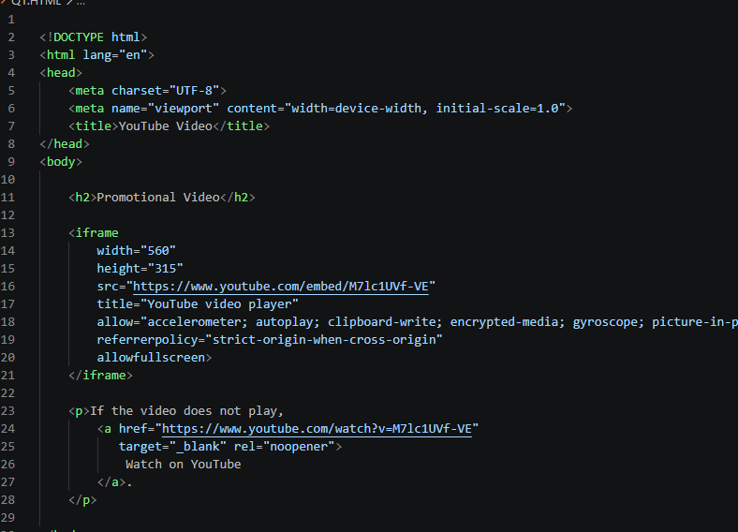
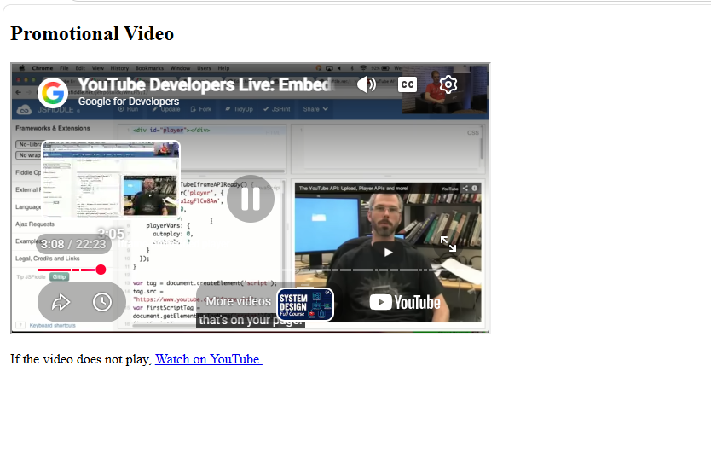

Separate Code — Question 2

Save as `question2.html`.

```

<!DOCTYPE html>
<html>
<head>
<title>Registration Form</title>
</head>
<body>
<h2>User Registration</h2>

<form action="/register" method="post">
<label>Name:</label>
<input type="text" name="username" required>
<br><br>

<label>Email:</label>
<input type="email" name="email" required>
<br><br>

<label>Password:</label>
<input type="password" name="password" required>
<br><br>

<button type="submit">Register</button>
</form>
</body>
</html>

```

Expected output:

A registration form containing Name, Email, Password, and Register fields/button.

When the user submits the form, the browser sends a POST request to `/register`. A working server endpoint is required to process the request; this HTML alone does not store the registration.

Key point

POST is suitable for submitting registration data, while HTTPS provides encryption during transmission.

Question 3: Choose the proper semantic element for navigation and justify its usage.

Correct answer: Option B — `<nav>`

Explanation:

The HTML `<nav>` element defines a section of a webpage containing major navigation links. It helps browsers, search engines, and assistive technologies understand the purpose of the links.

- `<div>` is a general-purpose container.
- `<nav>` identifies a navigation section.
- `<section>` groups related content.
- `<header>` represents introductory content or a page/section header.

Screenshort:
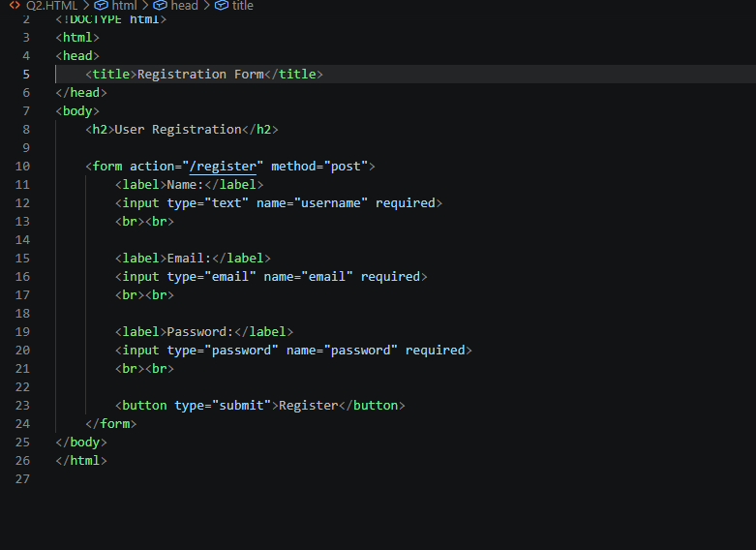
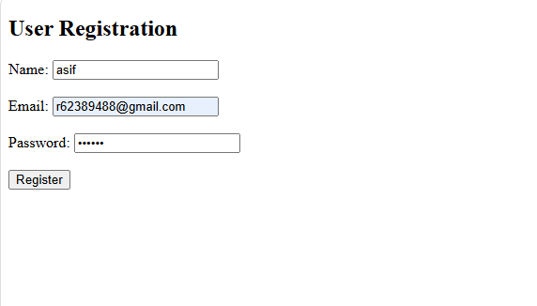

Separate Code — Question 3

Save as `question3.html`.

```

<!DOCTYPE html>
<html>
<head>
<title>Navigation Menu</title>
</head>
<body>
<header>
<h2>My Website</h2>
</header>

<nav>
<a href="#home">Home</a> |
<a href="#about">About</a> |
<a href="#services">Services</a> |
<a href="#contact">Contact</a>
</nav>

<section id="home">
<h3>Home</h3>
<p>Welcome to my website.</p>
</section>

<section id="about">
<h3>About</h3>
<p>Information about our website.</p>
</section>
</body>
</html>

```

Expected output:

A webpage displaying the heading “My Website,” followed by Home, About, Services, and Contact navigation links. Clicking Home or About moves to the corresponding section.

Justification: The `<nav>` element provides semantic meaning to the navigation links and improves accessibility.

Screenshort:
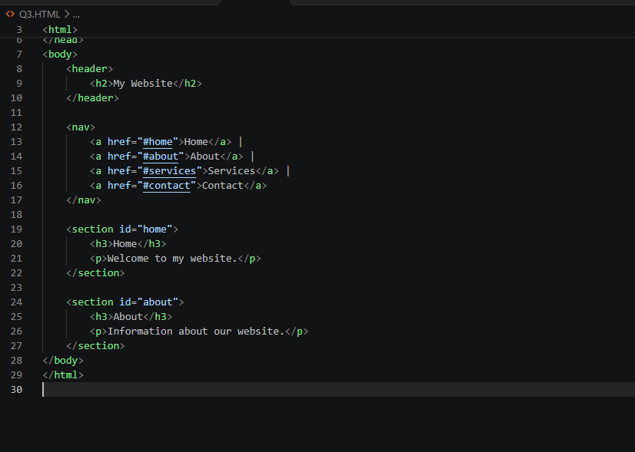
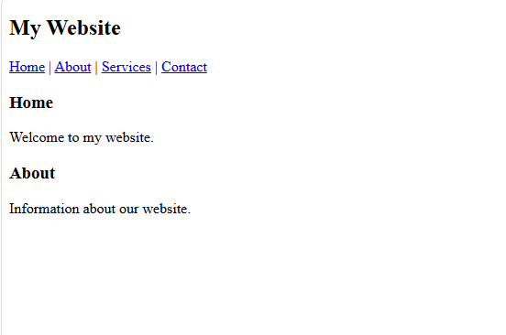

Question 4: Identify the correct XML syntax and explain the error in other options.

Correct answer: Option B

Correct XML snippet:

```
<note>
<to>User</to>
<from>Admin</from>
</note>
```

Explanation:

XML documents must be well-formed. Every opened element must have a matching closing element, tags must be properly nested, and the document must have a single root element.

### Errors in the other options

| Option | Error |
| ------ | --------------------------------------------------------- |
| A | The `<note>` opening tag is not closed. |
| B | Correct: all elements have matching closing tags. |
| C | The `<to>` element is incorrectly closed using `</from>`. |
| D | The closing `>` is missing from the `</note>` tag. |
Separate Code — Question 4

Save as `question4.xml`.

```

<?xml version="1.0" encoding="UTF-8"?>
<note>
<to>User</to>
<from>Admin</from>
<message>Welcome to the application</message>
</note>

```

Expected output:

The XML file contains the following data:

- To: User
- From: Admin
- Message: Welcome to the application

XML files do not automatically display a webpage when opened. You can inspect this file using a text editor or an XML editor. A valid XML parser should accept this document without syntax errors.

Justification: Option B is correct because all opening and closing tags match and the elements are properly nested.

Question 5: Choose the correct protocol for web communication and justify your choice.

Correct answer: Option B — HTTP

Explanation:

HTTP stands for Hypertext Transfer Protocol. It is used for communication between web clients, such as browsers, and web servers.

When a user opens a webpage, the browser sends an HTTP request to the server, and the server returns an HTTP response.

The other options are used for different purposes:

- FTP: Transfers files between systems.
- HTTP: Transfers web resources between clients and servers.
- SMTP: Sends email messages.
- SNMP: Monitors and manages network devices.

HTTPS is the secure version of HTTP, using TLS encryption to protect communication.
Screenshort:
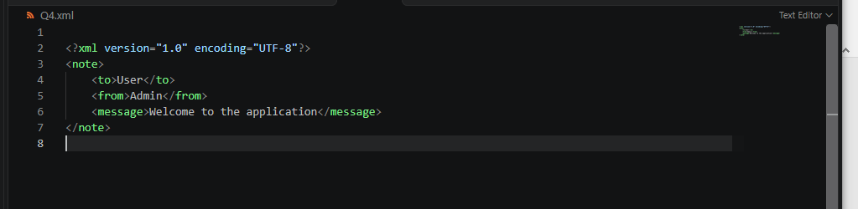
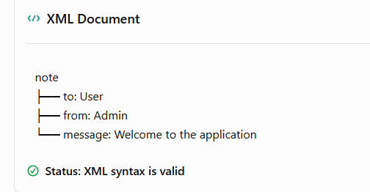

Separate Code — Question 5

Save as `question5.html`.

```

<!DOCTYPE html>
<html>
<head>
<title>HTTP Communication</title>
</head>
<body>
<h2>Web Communication</h2>
<p>HTTP enables communication between
a web browser and a web server.</p>

<button onclick="getData()">Send HTTP Request</button>

<p id="result"></p>

<script>
async function getData() {
try {
const response = await fetch(
"https://jsonplaceholder.typicode.com/todos/1"
);

const data = await response.json();

document.getElementById("result").textContent =
"HTTP Status: " + response.status +
" | Data: " + data.title;
} catch (error) {
document.getElementById("result").textContent =
"Request failed.";
}
}
</script>
</body>
</html>

```

Expected output:

Initially, the webpage displays:

- Web Communication
- An explanation of HTTP
- A Send HTTP Request button

After clicking the button, with internet access and the example service available, the webpage displays a successful HTTP status and the returned task title.

Example:

```
HTTP Status: 200 | Data: delectus aut autem
```

Justification: HTTP enables browsers and web servers to exchange requests and responses. The example uses HTTPS, which is HTTP protected by TLS.

## Final answer summary

| Question | Correct option | Answer |
| -------- | -------------- | ------------------- |
| 1 | B | `<video>` tag |
| 2 | B | POST method |
| 3 | B | `<nav>` element |
| 4 | B | Properly formed XML |
| 5 | B | HTTP protocol |

Screenshort:

